Assignment 5: Web-based Information Visualization
Niranjana Sathish Avilery
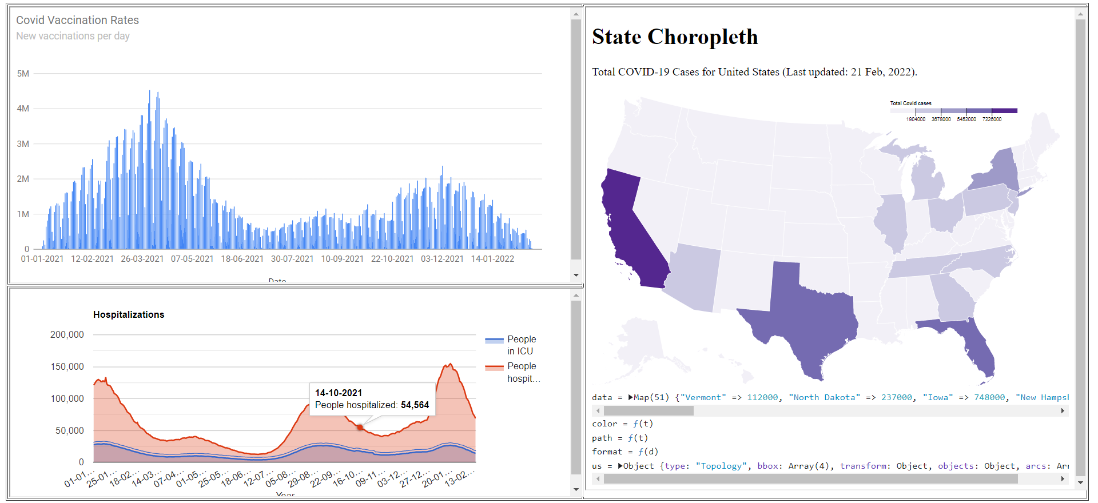
Link: https://people.rit.edu/na6322/Assignment5/Assignment.html
Tool Description: The tool is used to visualize COVID-19 data across three categories: total covid cases, new vaccinations per day, hospitalizations in the United States. The data was obtained from a public GitHub repository. The Line Chart shows the data of new vaccination rates per day whereas the Area Chart is used to display the number of people hospitalized and in ICU for each day (01/01/2021 – 01/14/2022). The Choropleth made using D3.js visualizes the total COVID cases detected so far in the United States.
Inference: Using the choropleth map, COVID-19 cases in California were at their highest as of February 21, 2022. The number of cases reported across the United States has exceeded 78 million, with California, Texas, and Florida reporting the highest numbers. It is evident from this that states with major cities have the highest COVID spreading rates. As for the vaccination rates, more people were vaccinated during the first few months of 2021 than the rest of the year. There is also an interesting correlation between the vaccination and Hospitalization graph. The number of vaccinations increases after each covid wave which led to hospitalizations. From the Area chart, we can see that there is an upward trend in people being admitted to the ICU during every wave of COVID-19.
Visual Thinking Algorithm used: The ‘Visual Queries’ algorithm (Algorithm 1) worked as a thinking tool that helped me visualize the data using Google Charts and d3JS. I wanted to see if there is some correlation between vaccination and hospitalization rates over a period of time and also to observe if there was a decrease in hospitalization and people admitted to the ICU due to the increase in vaccinations. On plotting, I checked the graphs for the first six months of 2021 to see if there is a pattern. This helped me understand that right after a peak COVID wave/hospitalization, there was an increase in vaccination rates. Also, a huge population got the vaccination during the first 6 months and the effect of the vaccine seems to be the reason for low hospitalization rates for few months after peak vaccination rates. The recent surge in hospitalization was probably due to the effectiveness of vaccine decreasing over time and also due to the rise of COVID variants. To understand the spread of COVID in each state, I had initially used a Bar Chart for the top 5 states. Later, I realized a Choropleth would help picture the spread for all the 50 states and see the exact count of the total number of cases on hovering the mouse. If I had more time, I would’ve used the ‘Brushing’ algorithm to understand the spread of COVID, hospitalizations, and vaccination in different states to get a different perspective.

